**Computers**

* Basic parts of a computer
* Hardware, software, applications, programmes
* A laptop X a desktop computer (advantages, disadvantages of each type)
* The most common problems with a PC and how to solve them
* The use of a PC (in general, your personal attitude to using a PC)
* The Internet (advantages, disadvantages, possible dangers of using the Internet – loss /misuse of personal data, photos, pornography, child abuse, addiction to games, social media,….)
* Applications and web pages you use the most and why, time you spend online
* Your computer skills
* The future of computers
* Labour saving machines, gadgets and their use in everyday life

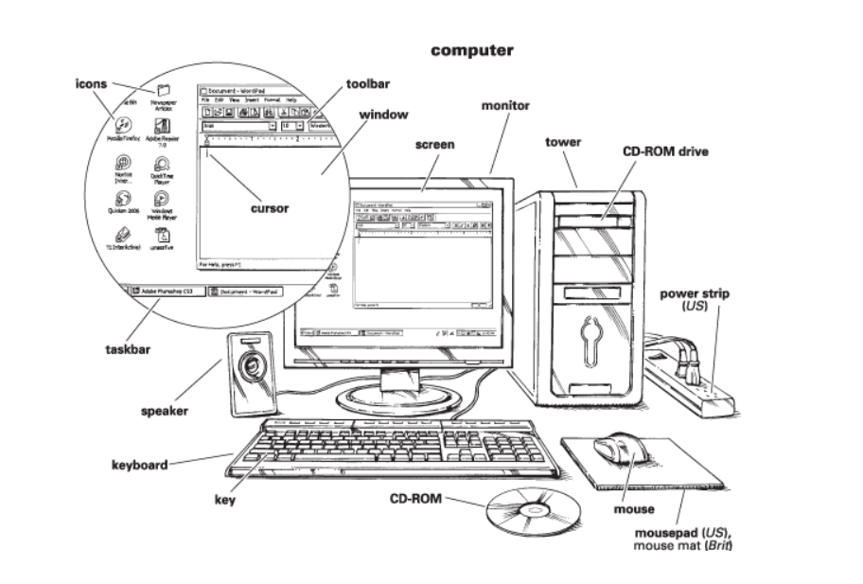

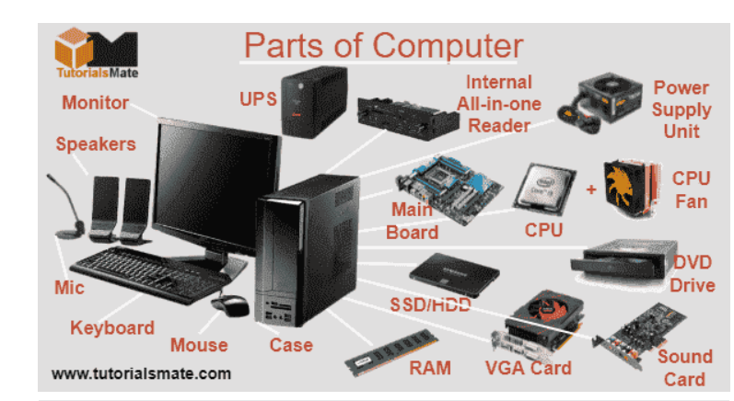

**Word list of computer parts vocabulary:**

|  |  |  |
| --- | --- | --- |
| * Motherboard * CPU/Processor * GPU * RAM * Case * Cooling * PSU * Monitor * Operating System * Input Devices * Mouse * Keyboard * Printer * Scanner * Microphone * Webcam * CD/DVD Drive * PMC Flash Memory * Toroid Inductor * Joystick | * Smart card * Headphones * Computer * Laptop * Tablet * Key * Screen * Hard drive (HDD) * CD-ROM drive * Flash drive * USB drive * Pen drive * Memory * Speakers * Chip * Cable * Computer case * Graphics card * Virtual reality headset | * Card reader * Device * Hardware * 3D glasses * Modem * External Hard disk * Floppy * Sound card * Network Card * Mobile Device Batteries |